Table of Contents
SQL SELECT and SELECT DISTINCT Methods 2
1. The SELECT statement in SQL 2
2. SQL SELECT Without DISTINCT 3
3. SQL SELECT DISTINCT Statement 4
4. The Difference Between SELECT and SELECT DISTINCT 4

SQL SELECT and SELECT DISTINCT Methods

1. The SELECT statement in SQL
In the first example, I used the SQL command that follows:
SELECT * FROM Customers;
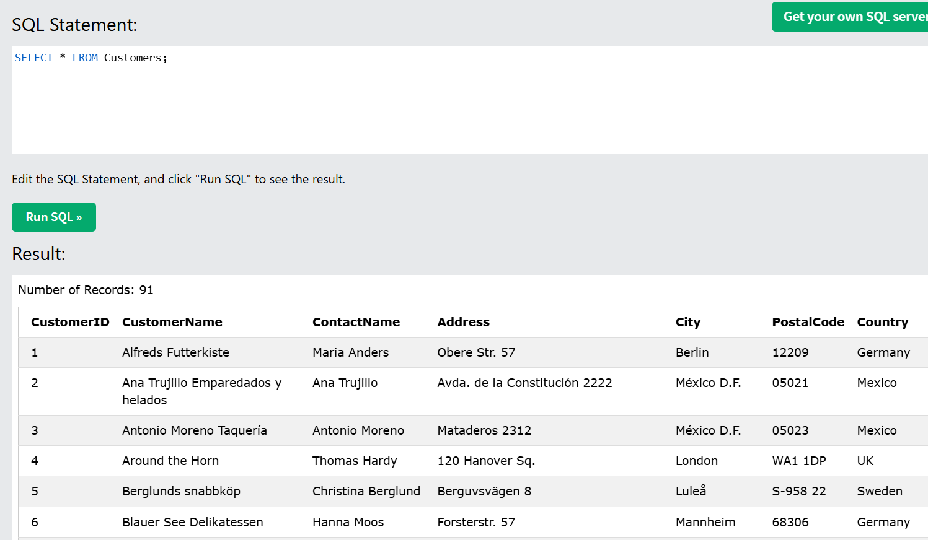
This command selects every column in the Customers table. Every field must be visible, as shown by the * mark. The result displayed 91 records with columns such as CustomerID, CustomerName, ContactName, Address, City, PostalCode, and Country.
I also used this command:
SELECT CustomerName, City FROM Customers;
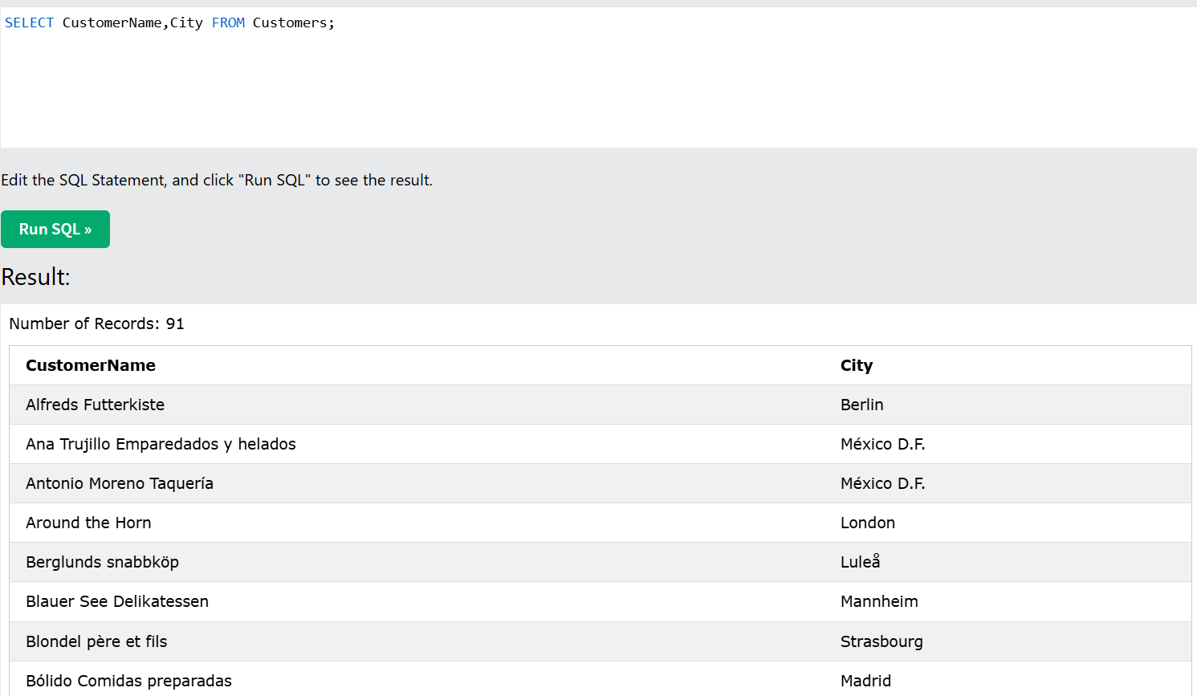
This command selects only the CustomerName and City fields from the Customers table. Instead of displaying every field, it merely displays the requested columns. The result displayed 91 records even though there were less columns.

2. SQL SELECT Without DISTINCT
I used this SQL command:
SELECT Country FROM Customers;
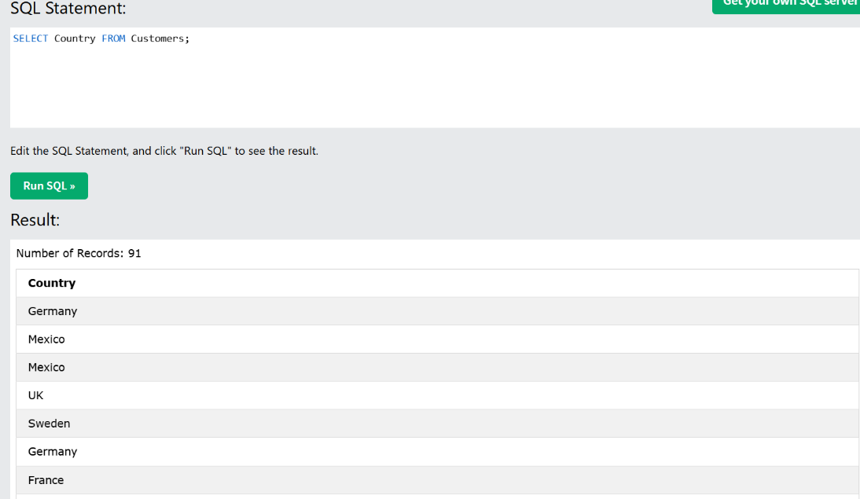
This command chooses the Country column in the Customers table. The result showed 91 records since each customer's country was shown. Because several consumers may be from the same nation, some countries, such as Mexico and Germany, showed more than once.

3. SQL SELECT DISTINCT Statement
I then carried out the following command:
SELECT DISTINCT Country FROM Customers;
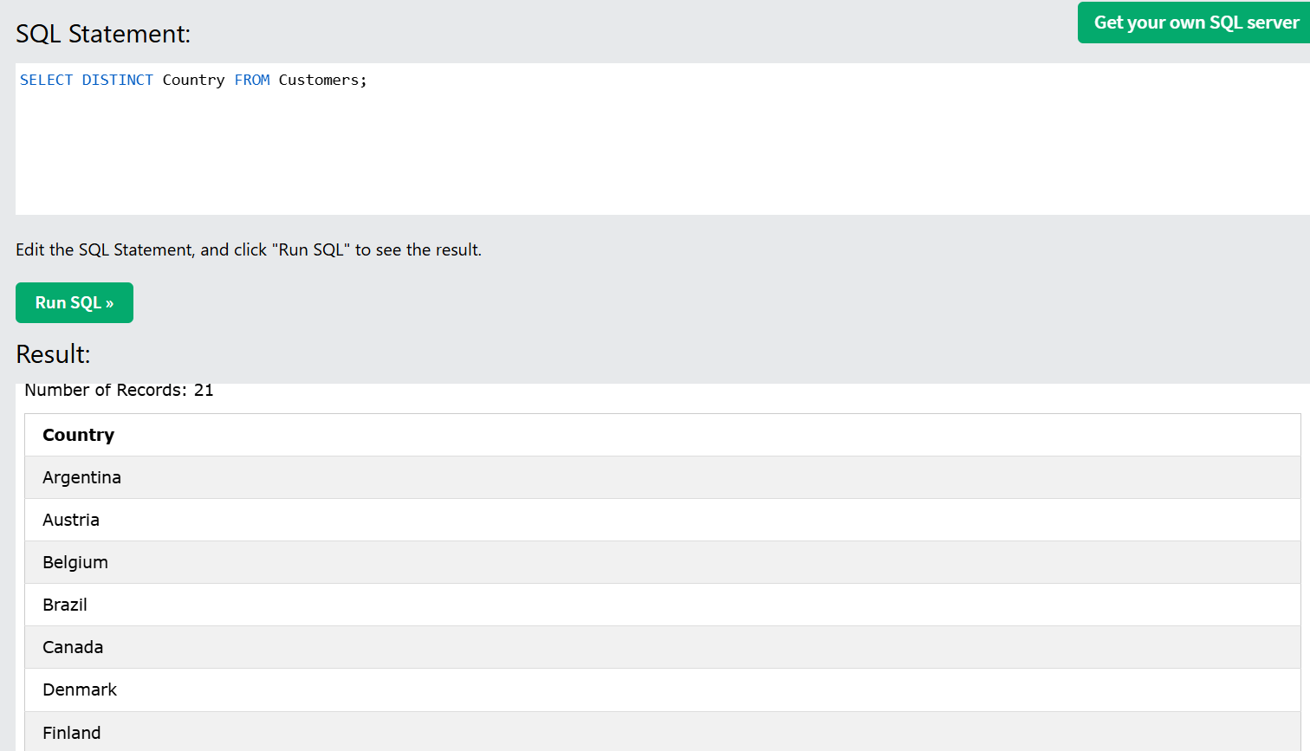
This procedure selects just the unique nation values from the Customers database. The result showed 21 records instead of 91 because duplicate country names were deleted. For example, Germany would show up more than once in the typical SELECT Country result, but it would only show up once when using SELECT DISTINCT.

4. The Difference Between SELECT and SELECT DISTINCT
After retrieving data from a table, a simple SELECT query shows all matched entries, including duplicate values. For example, SELECT Country FROM Customers allows the same country to appear numerous times by displaying the country for each client.
Using a SELECT DISTINCT command, duplicate values are deleted and only unique results are given. For example, SELECT DISTINCT Country FROM Customers only shows each country once. As a result, SELECT is used when all records are required, and SELECT DISTINCT is used when only unique data is required.

